|  |  |  |
| --- | --- | --- |
| Taylor Sloan | CSCI 251, Bob Robertson | MWF 2:00-3:30 |
|  |  |  |

1. 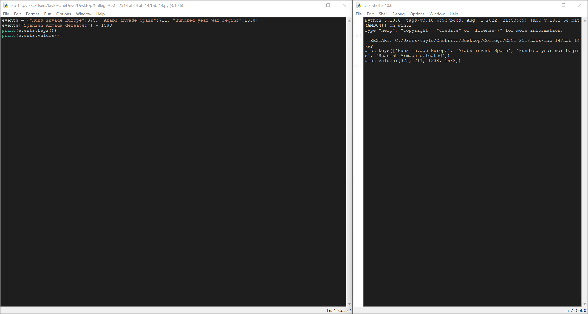
2. A computer screen capture

   Description automatically generated with medium confidence
3. Text

   Description automatically generated
4. 